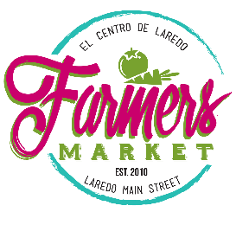
Office Use Only
Application: Approved
Declined

2022 APPLICATION FOR PARTICPATION
Business/Organization Name
Contact Name
Mailing Address
Phone
Email
Website
Facebook_____________ Instagram_____________ Twitter_______________ Other_______________________
Are you considered one of the following Vendor?
- Local- Farm, Produce, Eggs, and Honey
- Nurseries- plant sales outlet
- Texas Cottage Food Law producers- Baked goods that do not require refrigeration, such as cakes, cookies, breads, and pastries, candy, coated and uncoated nuts, unroasted nut butters, fruit butters, canned jams and jellies, fruit pies, dehydrated fruits and vegetables including dried beans, popcorn and popcorn snacks, cereal, including granola, dry mixes, vinegar, mustard, roasted coffee or dry tea, dried herbs or herb mixes, Whole (uncut) frozen fruits or vegetables, canned acidified plant-based foods with a pH of 4.6 or less, fermented vegetables with a pH of 4.6 or less, pickled fruits or vegetables with a pH of 4.6 or less
- Added Value- Handmade products, artwork, other products (must be approved by management)
- Specialty Foods- hot/cold foods.
- Non- Profit Organization
- Sponsor

Circle selling month(s) chosen: 2022 (the organization reserves the right make any necessary date changes weather/holiday permitting)
Jan 15 - Feb 12 - Mar 19 - Apr 16 - May 21 - June 18
Jul 16 - Aug 20 - Sep 17 - Oct 15 - Nov 19 - Dec 10
Please attach the following with the Vendor application:
- Product list (required)
- List of your employees, family members, and/or authorized representatives (required)
- Copy of sales tax permit (if applicable)
- Copy of Texas Cottage Food Law permit (if applicable)
- Copy of Food Handler's permit (if applicable)
- Health Department permit (if applicable)
- Fire Department permit (if applicable)

The market application does not guarantee acceptance into our Farmers Market. Submission of the vendor application is followed by a reviewed process (up to 4 weeks) and if there is an opening for your kind of product your chance of being selected increases. The market coordinator will follow up with a response. It is illegal for farmers to buy and resell agriculture products at a certified Farmers Market.

__________________________________ ___________________
Vendor Signature Date

